- Software Interface Services
- D1 Mechanical Arm Services Interface
D1 Mechanical Arm Services Interface
Last Updated On：2026-04-01 17:33:30
Introduction
The service starts when the steering gear arm of D1 is powered on, and the control function of the manipulator arm is realized by invoking the interface of the service. The specific functions are as follows.
joint Angle control of a single robot arm | By controlling the motor Angle of a single joint of the robot arm, the control of the robot arm
all joint Angle control of the robot arm | By controlling the motor Angle of all joints of the robot arm, the control of the robot arm
single arm joint motor enable/discharge force control | the control joint motor state is locked/free. In the free state, with the joint Angle feedback interface, drag memory teaching
all joint motors of the manipulator arm enable/unload force control | The state of all joint motors is controlled as lock/free. With the joint Angle feedback interface in free state, drag memory teaching
The power supply switch of the motor of the manipulator | controls whether to power the motor (can be used for emergency stop)
robotic arm position return to zero | In any position return to zero
robot arm joint Angle feedback | Feedback real-time Angle of robot arm joint
robot arm status feedback | Feedback the enable/discharge status and power-on status of the robot arm
command receive feedback | The feedback after receiving the control command is regarded as the successful reception
command execution feedback | Feedback after the control command is executed, which indicates that the command is successfully executed
Specification Parameters
Structural parameters
Model | D1-550
Weight | 3152g
Degrees of Freedom | 6 (degrees of freedom)+1 (gripper)
Arm length | 550mm (excluding jaws), 670mm (including jaws)
Rated load | 500g (including clamp weight)
Working radius | 550mm
Torque of each joint motor | J0: 3.3NM  J1: 3.3NM  J2: 1.7NM  J3: 1.7NM  J4: 1.7NM  J5: 1.7NM  J6: 1.7NM
Range of motion for each joint | J0: ±135°  J1: ±90°  J2: ±90°  J3: ±135°  J4: ±90°  J5: ± 135 °  Claw stroke: 0-65mm
Motor type | Bus servo

Electrical parameters
Power requirement | 24V 10A (15-48V)
Power | 240W
Controller | Integrated (4 x Cortex-A55 1.8GHz)
Communication method | RJ45 (Ethernet 100Mbps communication)+Type-C (serial port debugging)
Control Method | DDS Subscription
Control cycle | 10Hz
Mechanical arm structure diagram
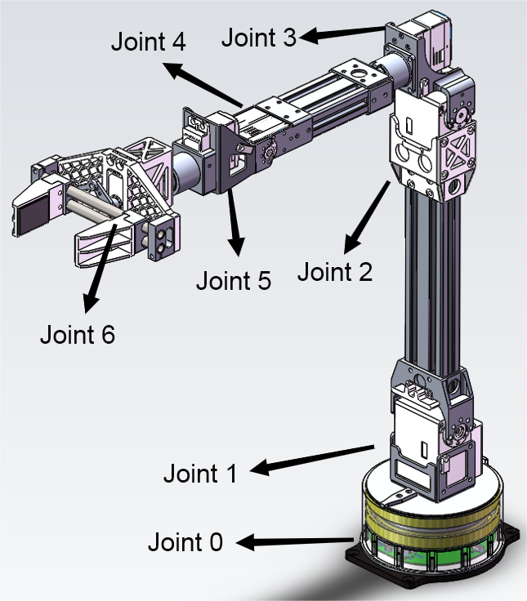
The robot arm basic 6 axis +1 clamp, starting from the base is 0, to the clamp is 6.
Interface Protocol
All data is transmitted using strings in Json format, including seq (unique identifier), address (instruction address code), funcode (instruction function code), and data (data content). data content can be nested with Json data.
The seq of the command to be sent is automatically generated by the calling end, except that the seq of the active message is 10 (write dead). In order to distinguish the sequence of reply messages, no parsing is required, and only the seq of this command is sent back when the reply is made.
function | seq | address | funcode | data | Example data | description
angle control of single robotic arm joint | The calling end generates | 1 | 1 | id, Angle, and delay_ms | {"seq":4,"address":1,"funcode":1",data":{"id": joint number,"angle": joint target angle,"delay_ms": execution time}} | id is the corresponding joint number, angle is the joint target Angle, delay_ms Execution time is temporarily set to 0
All robotic arm joint Angle control | The calling end generates | 1 | 2 | mode and angle0~6 | {" seq ": 4," address ": 1," funcode ": 2," data ": {" mode" : control mode, the angle0 ": joint Angle of 0," angle1 ": joint 1 Angle value," angle2 ": joint Angle value, 2" angle3 ": 3 joints Angle value," ang le4": Angle value of joint 4,"angle5": Angle value of joint 5,"angle6": Angle value of joint 6}} | are respectively the mode control mode and the joint Angle value of angle0~6. mode 0 is the small smoothing of 10Hz data, and mode 1 is the large smoothing of trajectory use
Enable/force discharge control of a single manipulator joint motor | The calling end generates | 1 | 4 | mode | {"seq":4,"address":1,"funcode":4,"data":{"id": joint id,"mode": enable mode}} | ID indicates the joint ID, mode is 0 to release force, and mode is 1 to enable
Enable/force discharge control of all mechanical arm joint motors | The calling end generates | 1 | 5 | mode | {"seq":4,"address":1,"funcode":5,"data":{"mode": enable mode}} | mode indicates that 0 is removed and mode 1 indicates that
power supply switch of the mechanical arm motor | The calling end generates | 1 | 6 | power | {"seq":4,"address":1,"funcode":6,"data":{"power": enable mode}} | power if 0 is powered off, power 1 is powered on
robotic arm posture returns to zero |  | 1 | 7 | none | is generated on the calling end {"seq":4,"address":1,"funcode":7} | None
mechanical joint Angle feedback | 10 | 2 | 1 | angle0~6 | {" seq ": 10," address ": 2," funcode ": 1," data ": {0" angle0 ": joint Angle value," angle1 ": joint 1 Angle value," angle2 ": joint Angle value, 2" angle3 ": joint 3 point of value," angle4 ": joint four angles Value,"angle5": Angle value of joint 5,"angle6": Angle value of joint 6}} | Feedback real-time Angle of the joint of the manipulator, upload frequency 10Hz
Robotic arm status feedback | 10 | 2 | 3 | enable_status, pow_status, and error_status | {"seq":10,"address":2,"funcode":3,"data":{"enable_status": enable status,"power_status": power-on status,"error_status": fault status}} | Provides the real-time status of the manipulator. enable_status Indicates that the function is enabled. 1 Indicates that the function is enabled. 0 Indicates that the function is removed. power_status: Indicates the power supply status. 1 indicates the power supply. 0 indicates the power supply. error_status indicates the fault status. 1 is normal, 0 is abnormal
Online status detection of mechanical arm motor | 10 | 2 | 4 | motor0_status, motor1_status, motor2_status, motor3_status, motor4_status, motor5_status, motor6_status | {"seq":10,"address":2,"funcode":4,"data":{"motor0_status":motor0 status,"motor1_status":motor1 status,"motor2_status":motor2 status,"mo tor3_status":motor3 status,"motor4_status":motor4 status,"motor5_status":motor5 status,"motor6_status":motor6 status}} | Feedback motor status, If the motor is faulty, the corresponding status is 0, and normally it is 1
feedback | The caller generates | 3 | 1 | recv_status | {"seq":10,"address":3,"funcode":1,"data":{"recv_status": Receive status}} | The reception is successful. If recv_status is 1, the reception is successful. A value of 0 indicates that the sent data is incorrect (the format is incorrect, cannot be parsed, is out of function scope, etc.)
command execution feedback |  | 3 | 2 | exec_status | is generated on the invoke end {"seq":10,"address":3,"funcode":2,"data":{"exec_status": execution status}} | If exec_status is 1, the execution succeeds, and 0, the execution fails
The service provides two interfaces to the outside world, namely rt/arm_Command and rt/arm_Feedback. rt/arm_Command sends data and command requests to the service. rt/arm_Feedback gets data uploaded by the service. Where rt/arm_
// generated from rosidl_generator_dds_idl/resource/idl.idl.em
// with input from unitree_arm:msg/ArmString.idl
// generated code does not contain a copyright notice

#ifndef __unitree_arm__msg__arm_string__idl__
#define __unitree_arm__msg__arm_string__idl__

module unitree_arm {

module msg {

module dds_ {

struct ArmString_ {
string data_;

};

}; // module dds_

}; // module msg

}; // module unitree_arm

#endif // __unitree_arm__msg__arm_string__idl__
Acquisition and use of SDK and sample programs
The SDK and sample program running environment of the robot arm rely on unitree_sdk2, and it is necessary to deploy unitree_sdk2 before the development of D1.
The SDK and sample programs for D1 can be downloaded here:
https://unitree-firmware.oss-cn-hangzhou.aliyuncs.com/tool/d1_sdk.zip
After the download is complete, create a folder in it, and use cmake to build and make to compile.
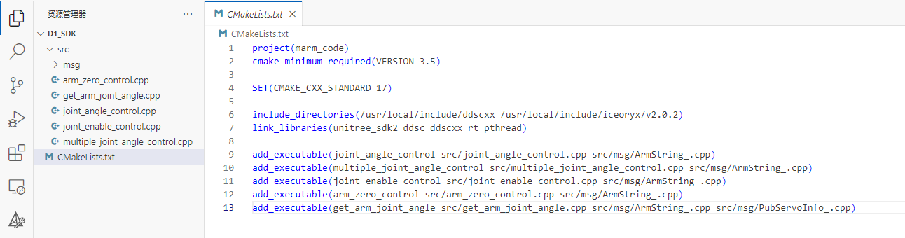
arm_zero_control.cpp: Robot arm zero_example program;
get_arm_joint_angle.cpp: Obtain the robotic arm joint Angle value sample program;
joint_angle_control.cpp: Robot arm single joint Angle control example program;
joint_enable_control.cpp: Robot arm joint enable control example program;
multiple_joint_angle_control: Robot arm multi-joint Angle control example program.
Among them, msg file is the D1 robot arm SDK interface file that we need to use. In the future, we only need to add these files in our own project. You can also copy the file to /usr/local/include, add it to the directory include_directories, and use link_libraries to link files . Currently, only ubuntu is supported. And depends on unitree_sdk2.
Robotic Arm Download
Gripper version: https://oss-global-cdn.unitree.com/static/90b2525be5d84531ab9814f48b2f86a7.zip
Grip-free version: https://oss-global-cdn.unitree.com/static/02c95ece8e354143b874a3c963241467.zip
STEP：STEP Simplified Model
D1-550 STEP: D1-550 STEP
D1-550 URDF: D1-550 URDF
D1-550 gripper open source files: D1-550 gripper open source files
Category | differences
gripper version | The end gripper can be opened and closed through the slider interface, which is suitable for the development of grasping tasks under simulation
gripless version | The end gripper has a fixed structure and is fixed to the end shaft of the manipulator. The gripper cannot be opened or closed. It is suitable for only cloud end pose simulation task
Use examples
1. Single joint Angle control of mechanical arm
Using the rt/arm_Command topic, assume that the generated seq value is 4 and set the Angle of joint 5 to 60. The data content for {" seq ": 4," address ": 1," code ": 1," data ": {" id" : 5, "Angle" : 60, "delay_ms" : 0}}
#include <unitree/robot/channel/channel_publisher.hpp>
#include <unitree/common/time/time_tool.hpp>
#include "msg/ArmString_.hpp"

#define TOPIC "rt/arm_Command"

using namespace unitree::robot;
using namespace unitree::common;

int main()
{
ChannelFactory::Instance()->Init(0);
ChannelPublisher<unitree_arm::msg::dds_::ArmString_> publisher(TOPIC);
publisher.InitChannel();

unitree_arm::msg::dds_::ArmString_ msg{};
msg.data_() = "{\"seq\":4,\"address\":1,\"funcode\":1,\"data\":{\"id\":5,\"angle\":60,\"delay_ms\":0}}";
publisher.Write(msg);

return 0;
}
2. Multi-joint Angle control of mechanical arm
Using the rt/arm_Command topic, it is assumed that the generated seq value is 4 and the joint Angle of the manipulator arm is {0, -60, 60, 0, 30, 0, 0, 0}. The data content for {" seq ": 4," address ": 1," funcode ": 2," data ": {" mode" : 1, "angle0" : 0, "angle1" : to 60, "angle2" : 60, "angle3" : 0, "angle4" : 30, "ang le5":0,"angle6":0}}
#include <unitree/robot/channel/channel_publisher.hpp>
#include <unitree/common/time/time_tool.hpp>
#include "msg/ArmString_.hpp"

#define TOPIC "rt/arm_Command"

using namespace unitree::robot;
using namespace unitree::common;

int main()
{
ChannelFactory::Instance()->Init(0);
ChannelPublisher<unitree_arm::msg::dds_::ArmString_> publisher(TOPIC);
publisher.InitChannel();

unitree_arm::msg::dds_::ArmString_ msg{};
msg.data_() = "{\"seq\":4,\"address\":1,\"funcode\":2,\"data\":{\"mode\":1,\"angle0\":0,\"angle1\":-60,\"angle2\":60,\"angle3\":0,\"angle4\":30,\"angle5\":0,\"angle6\":0}}";
publisher.Write(msg);

return 0;
}
3. Enable/unload force control of mechanical arm joint motor
Through the rt/arm_Command topic, assuming that the seq value generated at this time is 4, control all joint unloading force. The data content for {" seq ": 4," address ": 1," funcode ": 5," data ": {" mode" : 0}}
#include <unitree/robot/channel/channel_publisher.hpp>
#include <unitree/common/time/time_tool.hpp>
#include "msg/ArmString_.hpp"

#define TOPIC "rt/arm_Command"

using namespace unitree::robot;
using namespace unitree::common;

int main()
{
ChannelFactory::Instance()->Init(0);
ChannelPublisher<unitree_arm::msg::dds_::ArmString_> publisher(TOPIC);
publisher.InitChannel();

unitree_arm::msg::dds_::ArmString_ msg{};
msg.data_() = "{\"seq\":4,\"address\":1,\"funcode\":5,\"data\":{\"mode\":0}}";
publisher.Write(msg);

return 0;
}
The mode ranges from 0 to 80000. 0 is fully unloaded and 80000 is fully locked.
4. Robotic arm position and posture return to zero
Through the rt/arm_Command topic, assuming that the seq value generated at this time is 4, the manipulator is controlled to return to zero position. The data content is' {"seq":4,"address":1,"funcode":7} '
#include <unitree/robot/channel/channel_publisher.hpp>
#include <unitree/common/time/time_tool.hpp>
#include "msg/ArmString_.hpp"

#define TOPIC "rt/arm_Command"

using namespace unitree::robot;
using namespace unitree::common;

int main()
{
ChannelFactory::Instance()->Init(0);
ChannelPublisher<unitree_arm::msg::dds_::ArmString_> publisher(TOPIC);
publisher.InitChannel();

unitree_arm::msg::dds_::ArmString_ msg{};
msg.data_() = "{\"seq\":4,\"address\":1,\"funcode\":7}";
publisher.Write(msg);

return 0;
}
5. Obtain real-time joint Angle
The seq value of the instruction is fixed at 10, the upload frequency is 10Hz, and the data is distinguished by the address address +code function code, which requires callback monitoring.
#include <unitree/robot/channel/channel_subscriber.hpp>
#include <unitree/common/time/time_tool.hpp>
#include "msg/PubServoInfo_.hpp"
#include "msg/ArmString_.hpp"

#define TOPIC "current_servo_angle"
#define TOPIC1 "arm_Feedback"

using namespace unitree::robot;
using namespace unitree::common;

void Handler(const void* msg)
{
const unitree_arm::msg::dds_::PubServoInfo_* pm = (const unitree_arm::msg::dds_::PubServoInfo_*)msg;

std::cout << "servo0_data:" << pm->servo0_data_() << ", servo1_data:" << pm->servo1_data_() << ", servo2_data:" << pm->servo2_data_()<< ", servo3_data:" << pm->servo3_data_()<< ", servo4_data:" << pm->servo4_data_()<< ", servo5_data:" << pm->servo5_data_()<< ", servo6_data:" << pm->servo6_data_() << std::endl;
}

void Handler1(const void* msg)
{
const unitree_arm::msg::dds_::ArmString_* pm = (const unitree_arm::msg::dds_::ArmString_*)msg;

std::cout << "armFeedback_data:" << pm->data_() << std::endl;
}

int main()
{
ChannelFactory::Instance()->Init(0);
ChannelSubscriber<unitree_arm::msg::dds_::PubServoInfo_> subscriber(TOPIC);
subscriber.InitChannel(Handler);

ChannelSubscriber<unitree_arm::msg::dds_::ArmString_> subscriber1(TOPIC1);
subscriber1.InitChannel(Handler1);

while (true)
{
sleep(10);
}

return 0;
}
D1-T configuration and usage
Basic Demo
D1-T is the use of routers/switches to achieve data communication between two D1 robotic arms, the joint data of one robotic arm is input to the other robotic arm for execution. The default IP address of the D1 robot arm is 192.168.123.100. When using D1-T, we need to change the IP address of the other robot arm to 192.168.123.xxx, which is 192.168.123.99. We can also modify it according to our own needs.
The D1-T consists of two sets of D1 robotic arms, one of which has a hand-held claw at the end, which acts as the data acquisition end. Power on any robot arm and connect it to the router/switch through a network cable.
Router Configuration
We need to go to the background management interface of the router, change the WAN network segment to 192.168.123.xx in the location of the router IP address assignment.
After the modification is successful and saved, use your PC to connect to the router and run ping 192.168.123.100 through the terminal to check whether the communication is normal.
Change the IP address of the manipulator
After ensuring that the communication between the computer and the robot arm is correct, open the terminal and log in to the robot arm system through ssh, password 123, and the instructions are as follows.
ssh ubuntu@192.168.123.100
After the login is successful, enter the ip configuration path /etc/network, and change the IP address in the interface file to 192.168.123.99 through the vim command. After the modification, save the IP address and restart the system.
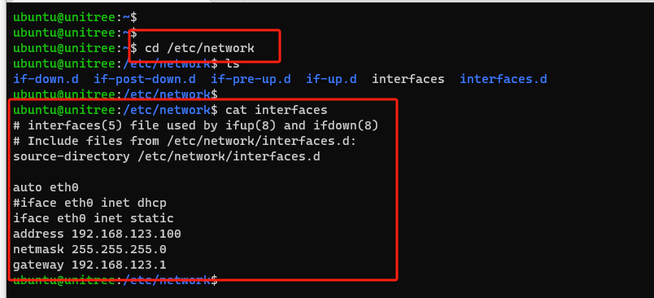
Power on the other robotic arm and connect it to the router. The IP addresses of the two robotic arms are 192.168.123.99 and 192.168.123.100 respectively. Run the ping command to check the two IP addresses to ensure normal communication.
Multi-Robot Arm Control
When using two or more robotic arms, there are two possible scenarios:
- Multiple robotic arms connected to the same computer
- The computer and robotic arms connected to the same router
To control these two or more robotic arms individually, there are two methods:
1. When multiple robotic arms are connected to the same computer, multiple network adapters (NICs) will appear on the computer. You only need to bind each robotic arm to the corresponding NIC.
First, we need to know which NIC the robotic arm to be controlled is bound to. You can get the NIC information using the following command:
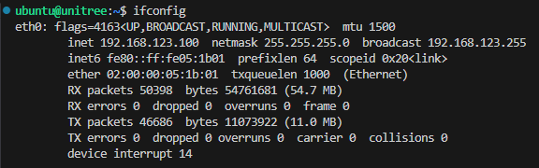
In this example, the robotic arm is bound to the eth0 NIC.
Open the official sample program "Arm Pose Zeroing", and in the first line of the main function you can see the initialization code for the robotic arm:
int main()
{
ChannelFactory::Instance()->Init(0);
ChannelPublisher<unitree_arm::msg::dds_::ArmString_> publisher(TOPIC);
publisher.InitChannel();

unitree_arm::msg::dds_::ArmString_ msg{};
msg.data_() = "{\"seq\":4,\"address\":1,\"funcode\":7}";
publisher.Write(msg);

return 0;
}
In the initialization, simply add the NIC name you want to bind to in order to control the robotic arm connected to that NIC:
ChannelFactory::Instance()->Init(0, "eth0");
2. When the computer and robotic arms are connected to the same router, the computer has only one NIC connected to all the robotic arms. In this case, you need to modify the internal driver files of the robotic arms.
First, you need to know that all control commands of the robotic arm are transmitted via DDS. By subscribing to the required topic in the program, you can get the desired messages.
Since all robotic arms use the same topic for control commands, to control different robotic arms within the same LAN, you just need to make each robotic arm’s control topic unique. Start by connecting only one robotic arm.
When modifying the robotic arm driver code, first stop the default running services:
sudo systemctl stop marm_controller.service
sudo systemctl stop marm_control.service
sudo systemctl stop marm_communication.service
sudo systemctl stop marm_subscripber.service

sudo systemctl disable marm_controller.service
sudo systemctl disable marm_control.service
sudo systemctl disable marm_communication.service
sudo systemctl disable marm_subscripber.service
After connecting to the robotic arm via SSH, enter the following command:
vim marm_code/src/marm_communication_node.cpp
You will see the internal driver code:
#include <unitree/robot/channel/channel_publisher.hpp>
#include <unitree/robot/channel/channel_subscriber.hpp>
#include <unitree/common/time/time_tool.hpp>

#include "msg/ArmString_.hpp"
#include "msg/PubServoInfo_.hpp"
#include "msg/SetServoAngle_.hpp"
#include "msg/SetServoDumping_.hpp"

#include <rapidjson/document.h>
#include <rapidjson/stringbuffer.h>
#include <rapidjson/writer.h>

#include <iostream>
#include <thread>
#include <chrono>

#define SubArmCommand_Topic "rt/arm_Command"
#define SubServoCurrentAngle_Topic "current_servo_angle"
#define PubArmFeedback_Topic "rt/arm_Feedback"
#define PubArmZero_Topic "arm_zero"
#define PubServoAngle_Topic "set_servo_angle"
#define PubServoAngleControl_Topic "set_servo_angle_control"
#define PubServoDumping_Topic "set_servo_dumping"
Find the topic that matches the control command in the "Arm Pose Zeroing" sample program:
#define SubArmCommand_Topic "rt/arm_Command"
Change it to a unique topic, for example:
#define SubArmCommand_Topic "rt/arm_Command_1"
After finishing, save and exit, wait for recompilation to complete, then restart the services and the robotic arm:
cd
cd marm_code/build/
make clean
make

sudo systemctl enable marm_communication.service
sudo systemctl enable marm_control.service
sudo systemctl enable marm_controller.service
sudo systemctl enable marm_subscripber.service

sudo reboot

sudo systemctl start marm_communication.service
sudo systemctl start marm_control.service
sudo systemctl start marm_controller.service
sudo systemctl start marm_subscripber.service
Once this operation succeeds, append a special suffix to all topics in the marm_code/src driver files inside the robotic arm, so that each arm has unique topics within the LAN. For example:
/marm_code/src/marm_communication_node.cpp
#define SubArmCommand_Topic "rt/arm_Command_1"
#define SubServoCurrentAngle_Topic "current_servo_angle_1"
#define PubArmFeedback_Topic "rt/arm_Feedback_1"
#define PubArmZero_Topic "arm_zero_1"
#define PubServoAngle_Topic "set_servo_angle_1"
#define PubServoAngleControl_Topic "set_servo_angle_control_1"
#define PubServoDumping_Topic "set_servo_dumping_1"
/marm_code/src/marm_control_node.cpp
#define PubServoAngle_Topic "set_servo_angle_1"
#define PubArmFeedback_Topic "rt/arm_Feedback_1"
#define SubArmZero_Topic "arm_zero_1"
#define SubServoAngleControl_Topic "set_servo_angle_control_1"
#define SubServoCurrentAngle_Topic "current_servo_angle_1"
/marm_code/src/marm_controller_node.cpp
#define PubArmFeedback_Topic "rt/arm_Feedback_1"
#define PubServoAngle_Topic "current_servo_angle_1"
#define SubServoAngle_Topic "set_servo_angle_1"
#define SubServoDumping_Topic "set_servo_dumping_1"
Possible compilation issues and solutions:
- Compilation failure: Delete the entire build folder and recompile.
- Errors caused by incorrect file time, such as:
- make: Warning: File 'Makefile' has modification time xxx s in the future
- Warning: File 'xxx' has modification time yyy s in the future
warning: Clock skew detected. Your build may be incomplete.
Fix by setting the system clock to the current time, for example:
sudo date -s yyyy-mm-dd
At this point, change the control command topic in the “Arm Pose Zeroing” sample program to match the unique topic. This way, you can control the specific robotic arm. The same principle applies if you want to get the angle data of a specific robotic arm. For example:
#include <unitree/robot/channel/channel_publisher.hpp>
#include <unitree/common/time/time_tool.hpp>
#include "msg/ArmString_.hpp"

#define TOPIC "rt/arm_Command_1"

using namespace unitree::robot;
using namespace unitree::common;

int main()
{
ChannelFactory::Instance()->Init(0);
ChannelPublisher<unitree_arm::msg::dds_::ArmString_> publisher(TOPIC);
publisher.InitChannel();

unitree_arm::msg::dds_::ArmString_ msg{};
msg.data_() = "{\"seq\":4,\"address\":1,\"funcode\":7}";
publisher.Write(msg);

return 0;
}
This completes the process of controlling a specific robotic arm.
Start the robotic arm program
A robot arm without a hand-held device is called an execution robot arm, and a robot arm with a hand-held device is called an acquisition robot arm.
To execute the robot arm, use the default program. To collect the robot arm, we need to stop the default program, use our acquisition interface program, and use the following command to stop the currently running service.
sudo systemctl stop marm_controller.service
sudo systemctl stop marm_control.service
sudo systemctl stop marm_communication.service
sudo systemctl stop marm_subscripber.service
This command will stop the factory program in the current system, if you need to stop permanently, continue to execute the following command.
sudo systemctl disable marm_controller.service
sudo systemctl disable marm_control.service
sudo systemctl disable marm_communication.service
sudo systemctl disable marm_subscripber.service
You can view the current status of the service by 'sudo systemctl statis service name'.

